Xcode 9 Bug 1 (Crash)

If you are experiencing this in your project,

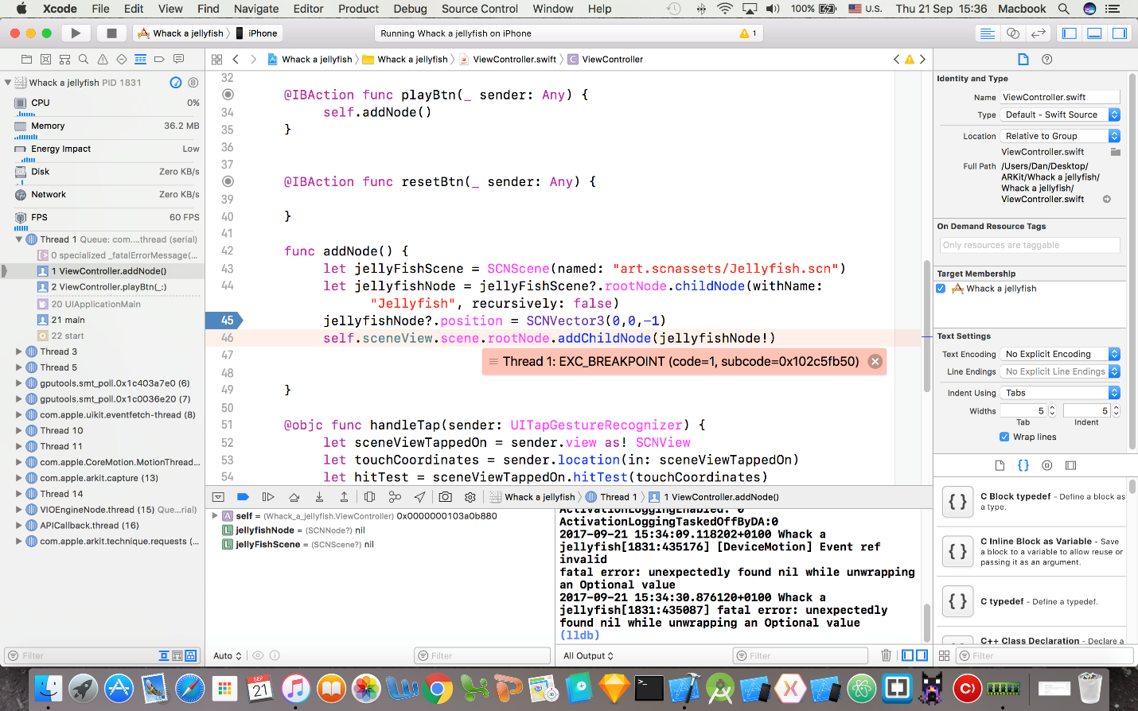

This crash occurs when Xcode can't find the Scene file that you're referencing. The problem is, every time the app is run, the scene file is moved out of the SCNAssets folder.

To fix the crash,  make sure to go into your **finder window**, **find**your project and locate your **art.scnassets folder**. Make sure that it is inside of your project's folder.  If not, drag it there. Then through the finder window, make sure that jellyfish.scn is **inside of art.scnassets,**if it's not, **drag it there.** **If the scn file doesn't show at all!** delete the scn file you have in your project, and drag another one into your scnassets folder through **finder,** not through Xcode.